Travel Policies, Procedures, and Tips

This document contains information regarding travel policies and procedures to provide guidance to travelers and assist travelers in avoiding some common pitfalls. More detailed information regarding travel guidelines is provided in PM-13 University Travel Regulations.

- Prior Approval for Travel Form
Prior to your travel date a Prior Approval for Travel form must be approved by the Business Office and it must include the appropriate funding source. Payment for registration fees and/or flights will not be made until the form is submitted with the appropriate signatures. Prior approval amounts are best-guess estimates, and it is better to over-estimate than under-estimate to prevent a prior approval from needing to be re-approved.

- Airfare
The state travel agency is Christopherson Business Travel and flights are required to be booked through the airportal at https://app.cbtat.com/. Travelers need a travel profile prior to booking a flight which is requested via Christopherson here: https://legacy.cbtravel.com/business/profile/stateofla/. You must choose the appropriate Agency Name: LSU HSC NO PUBLIC HEALTH – CBA in order for flights to be charged to the School’s central billing account (CBA). To charge to the School CBA, select “CBA card …1111.” To pay with a personal credit card, select “Add credit card.”

Travelers may be reimbursed a maximum of one day prior and one day after the dates of the conference. It is the traveler’s responsibility to choose the most economical, reasonable flight needed for the business travel. If personal days are included, the traveler must inform the Business Office before making the reservation and airfare quote documentation will be required.

- Registration
Registration may be paid in advance by the traveler or may be charged directly to the school via a procurement card (p-card). Please contact the Business Office in advance if you would like registration charged to a school p-card.

- Lodging
- General Info
Hotels are reserved and paid for by the traveler, and travelers must be mindful of:
1) the reimbursable rate based on the GSA lodging rates (which do not include taxes/fees) for routine travel; OR
2) the designated conference hotel and designated conference rate for the conference/meeting. Documentation of the conference hotel and rate must be included with the prior approval and the justification section of the prior for conference lodging must be completed and approved.
3) The rate for each night of lodging must not exceed the approved lodging rate

- Conference/Non-routine Meeting Travel
If a traveler chooses to not stay at the designated conference hotel, the traveler will be reimbursed at the GSA lodging rates, unless the traveler documents non-availability at the conference hotel. If the conference hotel is not available than the traveler may be reimbursed up to the conference rate.
If there are multiple designated conference hotels, then the traveler must chose the hotel with the lowest rate and must provide documentation to show the hotel available has the lowest rate. (date of search must be visible and the date must be the same for all searches Conf Hotel & Rate Availability Search Exs.)

- Routine Travel/Meeting Without Designated Hotel
Lodging is reimbursed at GSA lodging rates. If lodging at this rate cannot be found, at least two reasonable hotel quotes must be provided and the least expensive hotel chosen. In this scenario, a traveler may be reimbursed at the actual routine lodging costs. The quotes must be screenshots from the website obtained on the date of booking and the search date must be included. This method of quote documentation cannot be used for conferences/meetings with a designated hotel. Average nightly rate quotes will not be accepted. Documentation must be included with the prior form and the justification section for the hotel to exceed the designated GSA rate must be completed and approved.

- Car Rentals
Car rental requests must be justified and approved in advance on the Prior Approval for Travel form. Enterprise, National, and Hertz are the contracted agencies for in-state and out-of-state travel. For the corporate rental discount code, please email the Business Office.

Fuel receipts are required for fuel reimbursement. Only the cost of rental for compact or standard/intermediate models are reimbursable, unless 1) non-availability documentation is submitted or 2) the vehicle will be used to transport more than two individuals or equipment.

- Mileage
If a traveler uses a personal vehicle, mileage is reimbursed at $0.625 per mile (effective 10/01/22). To request reimbursement, a Travel Expense Voucher Mileage Log listing the complete address for each leg of the trip is required. In addition, mileage verification documentation must be submitted in the form of 1) a website mileage calculator or 2) odometer readings. The traveler should always claim the lesser of the miles from their official domicile or from their residence.

When use of a personal vehicle is chosen for the traveler’s convenience for out-of-state travel, the traveler will not be reimbursed for en-route expenses. The mileage reimbursement on the basis of $0.625 per mile may not exceed the cost of the lowest logical airfare quote obtained at least 14 days prior to the trip departure date.

- Reimbursement Request
Within two weeks of trip return, a completed Travel Expense Voucher Form must be submitted with any relevant receipts and documentation for reimbursement. It is permissible to submit vouchers on a monthly basis if traveling regularly.

VIII: Other Travel Information

- Lodging Receipts: Must have a $0 balance or read paid in full and must be itemized.

- Meals: Receipts are not required and are reimbursed per diem based on GSA meal rates. First and last day meal rates are limited to 75% of the daily M&IE rates for the travel destination. Note: Departure/Arrival time of travel is no longer applicable, except student group trips.

- 1) New Orleans Airport Parking: Receipts are required for any one of the three options - Surface Lot at $18 per day, Airline Economy Garage at $12 per day, or USPark at $14 per day. If you make a reservation at https://www.uspark.net/locations/veterans/reservations/louisiana-state-employees-reservation-form/, the LA state employee reservation coupon will be emailed or texted to you and must be presented upon entry/exit. If a reservation is not made, a state issued photo ID is required at entry/exit.

- Ground Transportation Tips: Reimbursed up to 20% of the fare. Receipt must show tip amount.

- Incidental Expenses (IE): Include tips for valets, porters, baggage carriers, hotel staff, etc. Must not exceed $5 per day. Parking receipt required.

- State Employee Tax Exemption: A Travel Tax Exempt Form is available for in-state lodging and rental car. The form can be approved by your department’s business office. A separate form is required for each trip.

- Complimentary Travel Reporting: Travel expenses covered by a third party are subject to the reporting requirements in R.S. 42:1111 Code of Governmental Ethics. Any public servant who accepts complimentary admission, lodging, or transportation to and from an educational or professional development seminar or conference shall file the BOE Complimentary Travel Form with the Board of Ethics within 60 days after such acceptance. Forms should not be submitted with estimates. If the public servant does not know the amount by the due date, the form should be submitted with a cover letter explaining such. Once the public servant knows the exact amounts, an amended form should be submitted. The Dean must sign as agency head and the employee must submit the form to the Board of Ethics. Exception: The form is not required if the travel expenses are being paid by a State or Government Entity (e.g. State of Louisiana, NIH or LSUHSC Foundation).

- Travel Prior, Annual Leave, Off-Campus Activity Leave, BOE Complimentary Travel Form, and PM-11 Requirements Guide:

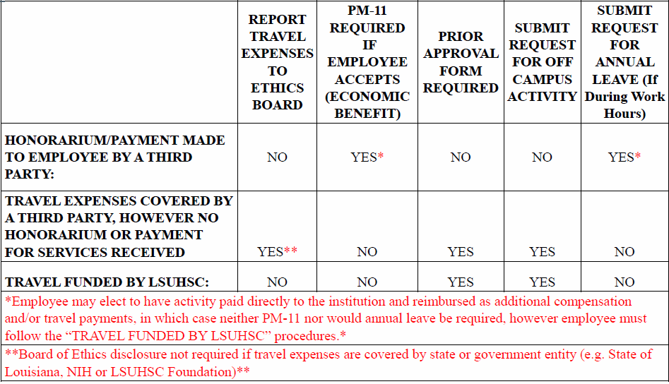

CM-67- Work- Related Off-Campus Activity Policy

Appendix A2 is a Summary of Policy Rates from October 1, 2022 - June 30, 2023

