Booking through Christopherson AirPortal – SAP Concur

IMPORTANT** Flight requests should only be made Monday through Friday before 2:30p.m. to ensure that they can be approved on the same day.

- Once your profile has been approved in AirPortal, select “Book/Manage Online Trips”
- Click TWICE to be directed to SAP Concur https://us2.concursolutions.com/home.asp

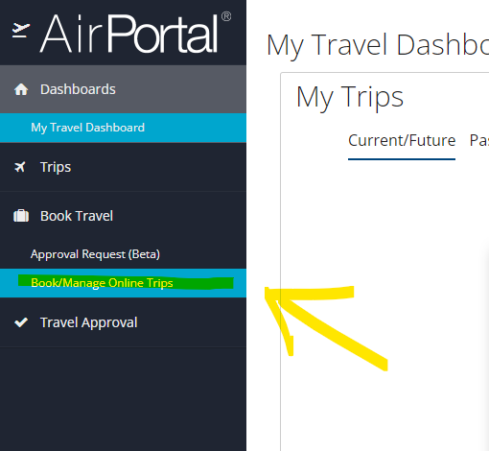

- Enter dates and airport information to search for flights
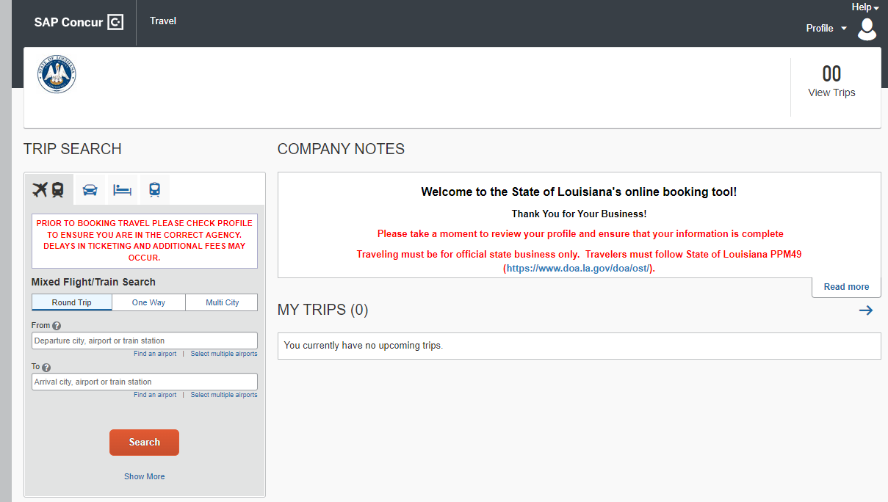

- Once you’ve chosen your flight, select “View Fares”

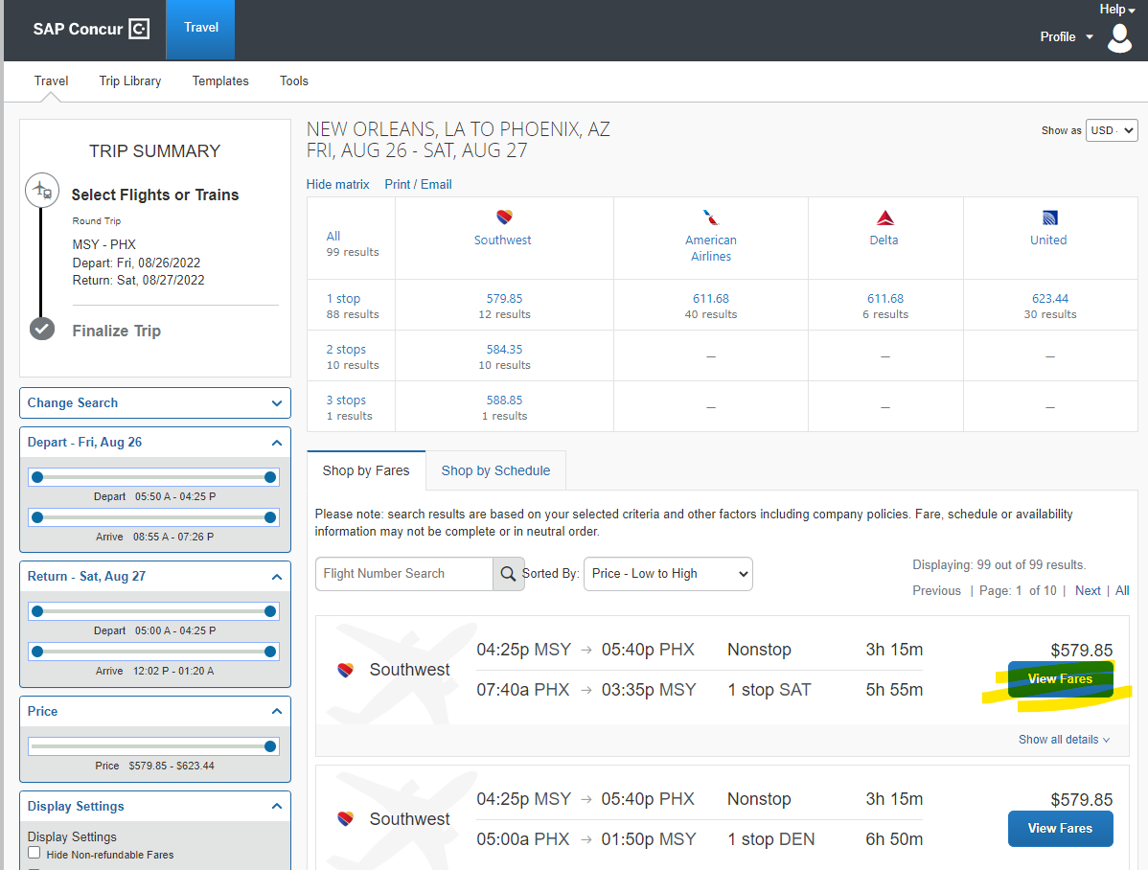

- Click on the dollar amount of your flight (this is a blue button)

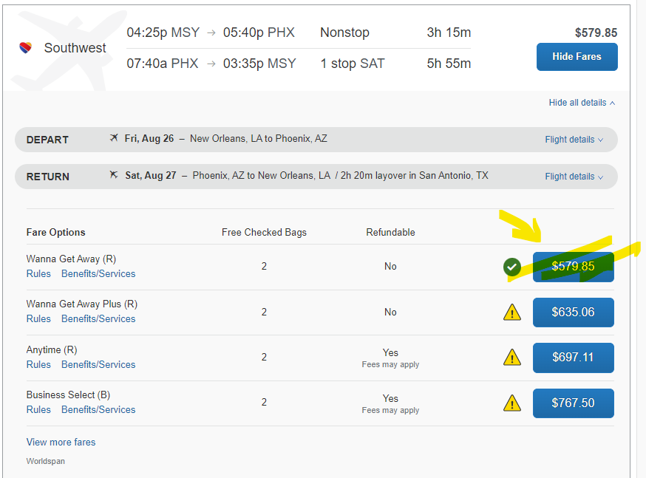

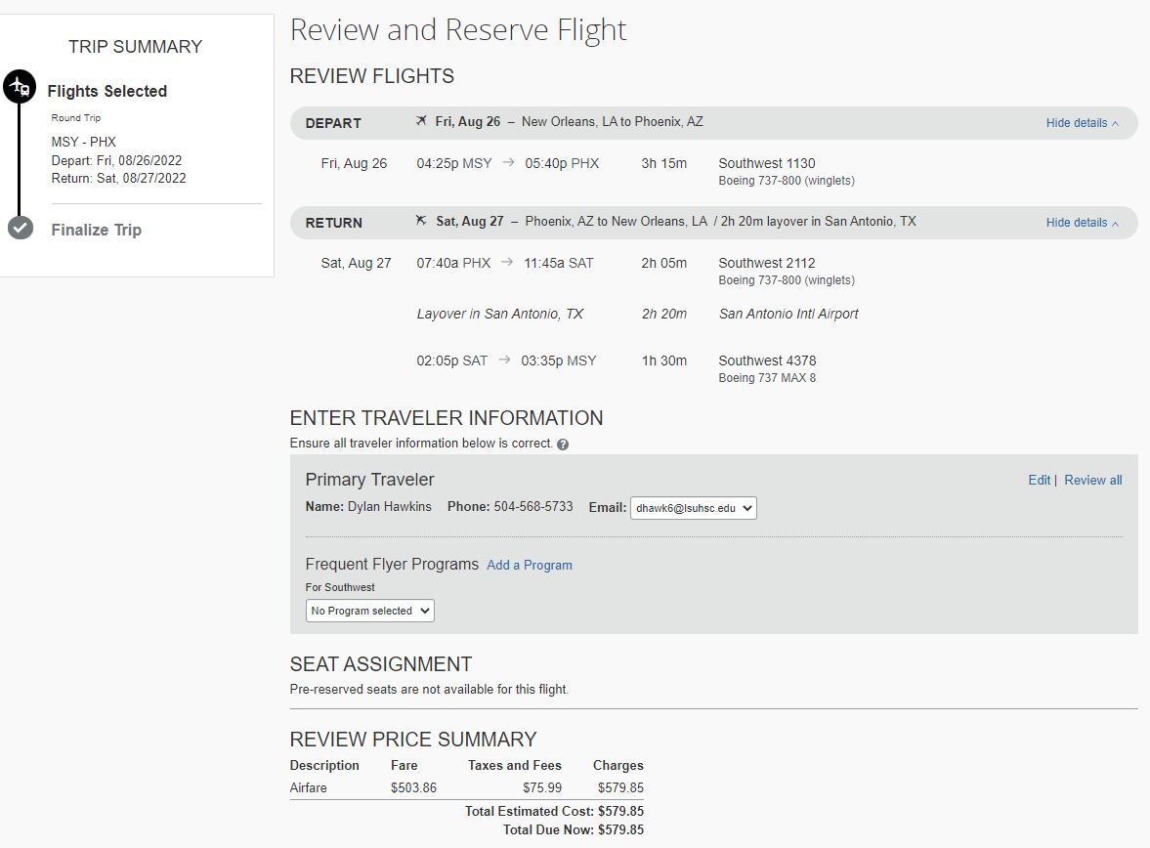

- Select CBA card, and click “Reserve Flight and Continue”
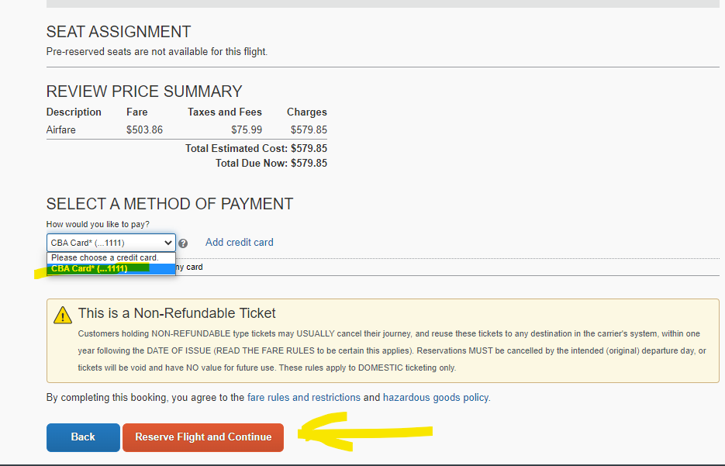
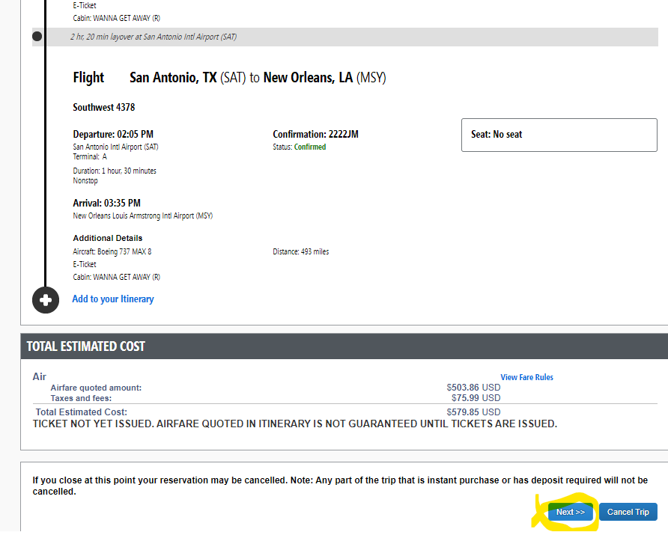

- Include a Trip Description
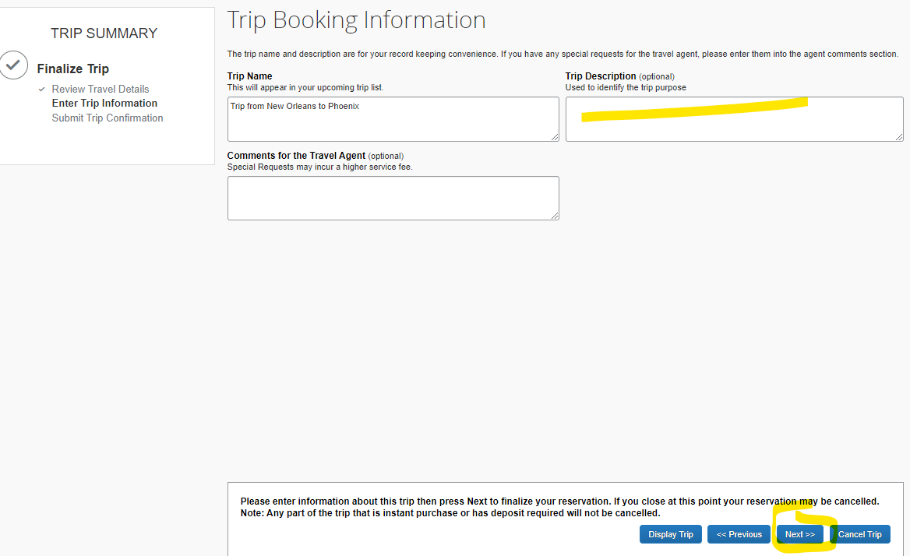

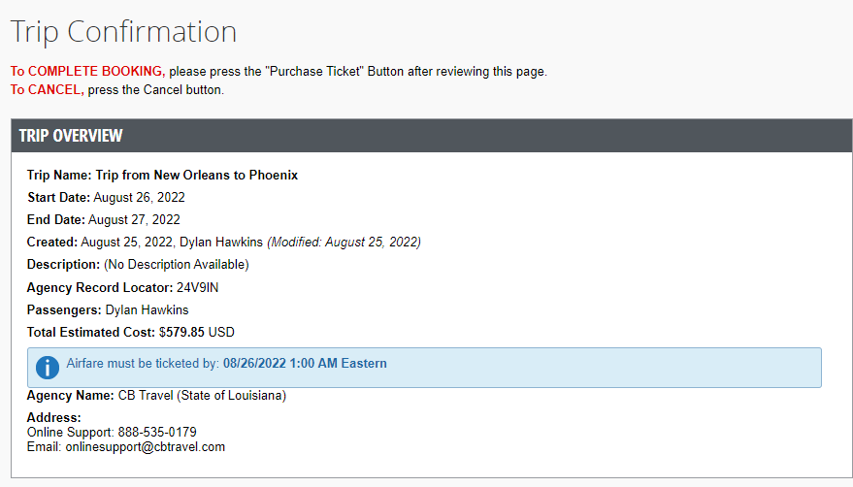

- Select “Purchase Tickets”
  - NOTE: this does NOT book your flight. It will notify the Business Office to review and approve your flight.
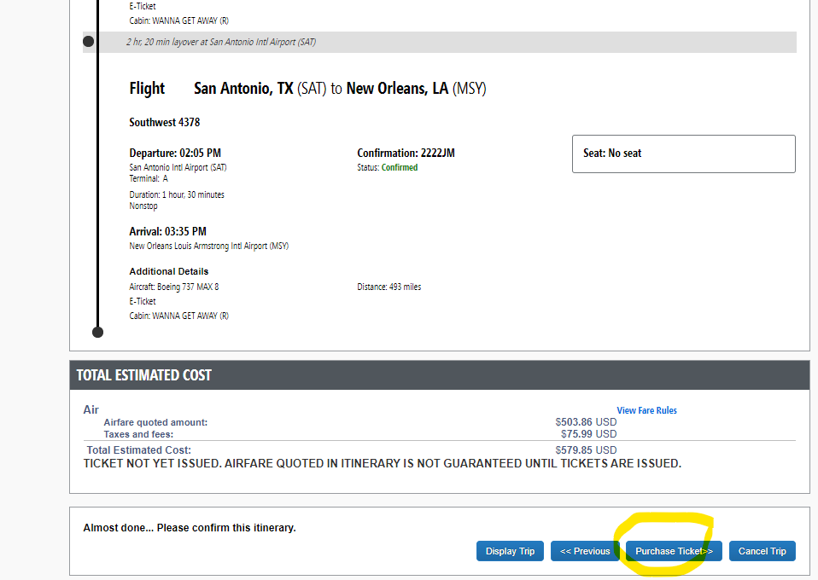

Make sure you are completing this Monday through Friday BEFORE 2:30p.m. for approval.

