Travel Policies, Procedures, and Tips

This document contains information regarding travel policies and procedures to provide guidance to travelers and assist travelers in avoiding some common pitfalls. More detailed information regarding travel guidelines is provided in the Travel Pocket Guide and PM-13 University Travel Regulations.

- Prior Approval for Travel Form
Prior to your travel date a Prior Approval for Travel form must be approved by the Business Office and it must include the appropriate funding source. Payment for registration fees and/or flights will not be made until the form is submitted with the appropriate signatures. Prior approval amounts are best guess estimates, and it is better to over-estimate than under-estimate to prevent a prior approval from needing to be re-approved.

- Airfare
The new travel agency is Christopherson Business Travel.
https://www.lsuhsc.edu/administration/accounting/shorts_travel_management.aspx

Flights must be booked through the Christopherson Business Travel Airportal at https://app.cbtat.com/. You will need to create a profile at https://legacy.cbtravel.com/business/profile/stateofla/. If you received an email from Airportal to transfer your profile from Shorts Travel Agency, you will not need to create a new profile. Flights may be paid for in advance by the traveler or may be charged to the School’s central billing account (CBA). Information is pending on how to select the school’s CBA.

You are allotted one day before and after your event for travel. It is the traveler’s responsibility to choose the most economical, reasonable flight needed for the business travel. If personal days are included, the traveler must inform the Business Office before making the reservation and airfare quote documentation will be required.

- Registration
Registration may be paid in advance by the traveler or may be charged directly to the school via a procurement card (p-card). Please contact the Business Office in advance if you would like registration charged to a school p-card.

- Lodging
- General Info
Hotels are reserved and paid for by the traveler and travelers must be mindful of the reimbursable rate based on: 1) the city of travel outlined in the tiers of the Travel Pocket Guide for routine travel or 2) the designated conference hotel and designated conference rate for the conference/meeting. It is recommended that travelers send the Business Office their lodging documentation prior to booking.

Only the first night of lodging should be pre-paid to secure the reservation. The remainder of the payment should be made upon checkout. If travel is canceled for any reason and the total cost of lodging was pre-paid, only the first night of lodging may be allowed as a University expense. The additional prepaid lodging days will
be the responsibility of the traveler.

- Conference/Non-routine Meeting Travel
Unless a traveler chooses to lodge at or below the city rate in the Travel Pocket Guide, the traveler is required to
stay at a designated conference hotel. The rate for each night must not exceed the designated conference rate.
If a traveler stays at a non-conference hotel and the conference hotel(s) is (are) available or the traveler does
not submit the proper lodging documentation, the maximum reimbursement will be at the city rate. Conference hotels are assumed to be available unless documentation to the contrary is submitted.

Documentation of all conference hotel names and conference rates must be provided. Of the designated conference hotels, the traveler must choose the hotel with the lowest rate. If this conference hotel is unavailable or only available above the designated rate, the traveler must provide documentation of non-
availability for their dates of stay or increased rate (date of search must be visible and the date must be the
same for all searches) and select the conference hotel with the next lowest rate. If all conference hotels are
unavailable or only available above their designated rates, the traveler may select a non-conference hotel up to
the lowest designated conference hotel rate. See Conf Hotel & Rate Availability Search Exs.

- Routine Travel/Meeting Without Designated Hotel
Lodging is reimbursed at the city rate listed in the Travel Pocket Guide. If lodging at this rate cannot be found, at least three reasonable hotel quotes must be provided and the least expensive hotel chosen. In this scenario, a
traveler may be reimbursed at the actual routine lodging costs. The quotes must be screenshots from the
website obtained on the date of booking because hotel rates frequently change and search date must be included. Average nightly rate quotes will not be accepted. This method of quote documentation cannot be used
for conferences/meetings with a designated hotel.

- Car Rentals
Car rental requests must be justified and approved in advance on the Prior Approval for Travel form. Specific agencies must be used for in-state (Enterprise) and out-of-state (Enterprise, National, and Hertz) travel. The discount number is L142795 and the Pin is STA for in-state rental. The corporate account number is 70592 for out-of-state rental. Travelers must call to apply the code for out-of-state travel.

The contracted rate includes liability insurance. Concession fees for rental car agencies located in the airport, additional insurance, and refueling services are not reimbursable. Fuel receipts are required for fuel
reimbursement. Only the cost of rental for compact or standard/intermediate models are reimbursable, unless 1) non-availability documentation is submitted or 2) the vehicle will be used to transport more than two individuals.

- Mileage
If a traveler uses a personal vehicle, mileage is reimbursed at $0.56 per mile. To request reimbursement, a Travel Expense Mileage Log listing the complete address for each leg of the trip is required. In addition, mileage verification documentation must be submitted in the form of 1) a Google Map type document or 2) odometer readings. Trip-odometer readings do not qualify as mileage verification. The traveler should always claim the lesser of the miles from their official domicile or from their residence.

When use of a personal vehicle is chosen for the traveler’s convenience for out-of-state travel, the traveler will not be reimbursed for en route expenses. The mileage reimbursement on the basis of $0.56 per mile may not exceed the cost of the lowest logical airfare quote obtained at least 14 days prior to the trip departure date.

- Reimbursement Request
Within two weeks of trip return, a completed Travel Expense Voucher must be submitted with any relevant receipts and an agenda (if provided) for reimbursement. Travel forms and supporting documentation should be submitted using one-sided printing. It is permissible to submit vouchers on a monthly basis if traveling regularly.

VIII: Other Travel Information

- Lodging Receipts: Must have a $0 balance or read paid in full.

- Meals: Receipts are not required and are reimbursed per diem based on travel times and city of stay. See the Travel Pocket Guide.

- New Orleans Airport Parking: Uncovered parking at USPARK on Veterans Blvd is the preferred parking lot and is reimbursable with a receipt at $10.35 per day (including taxes/fees). If you make a reservation at https://www.uspark.net/louisiana-reservations/, the LA state employee reservation coupon will be emailed or texted to you and must be presented upon entry/exit. If a reservation is not made, a state issued photo ID is required at entry/exit. If parking at another facility in New Orleans, an employee may be paid actual expenses for uncovered parking with a receipt. USPARK is not accepting travel tax exempt forms at this time.

Baton Rouge Airport Parking: Parking is reimbursable up to $4.50 per day. The BR Airport Parking Certificate is required along with a state issued photo ID.

- Ground Transportation Tips: Reimbursed up to 20% of the fare. Receipt must show tip amount.

- Valet Parking Tips: Must not exceed $5 per day. Parking receipt required.

- Hotel Allowances: Tips may be reimbursed one time up to $5 upon each hotel check in and upon each hotel checkout.

- Airport Allowances: Tips may be reimbursed one time up to $5 for the airport outbound departure trip and for the inbound departure trip. Maximum total for entire trip is not to exceed $10.

- State Employee Tax Exemption: A Travel Tax Exempt Form is available for lodging and rental car. The form can be approved by your department’s business office. A separate form is required for each trip.

- Complimentary Travel Reporting: Travel expenses covered by a third party are subject to the reporting requirements in R.S. 42:1111 Code of Governmental Ethics. Any public servant who accepts complimentary admission, lodging, or transportation to and from an educational or professional development seminar or conference shall file the BOE Complimentary Travel Form with the Board of Ethics within 60 days after such acceptance. Forms should not be submitted with estimates. If the public servant does not know the amount by the due date, the form should be submitted with a cover letter explaining such. Once the public servant knows the exact amounts, an amended form should be submitted. The Dean must sign as agency head and the employee must submit the form to the Board of Ethics. Exception: The form is not required if the travel expenses are being paid by a State or Government Entity (e.g. State of Louisiana, NIH or LSUHSC Foundation).

- Travel Prior, Annual Leave, Off-Campus Activity Leave, BOE Complimentary Travel Form, and PM-11 Requirements Guide:

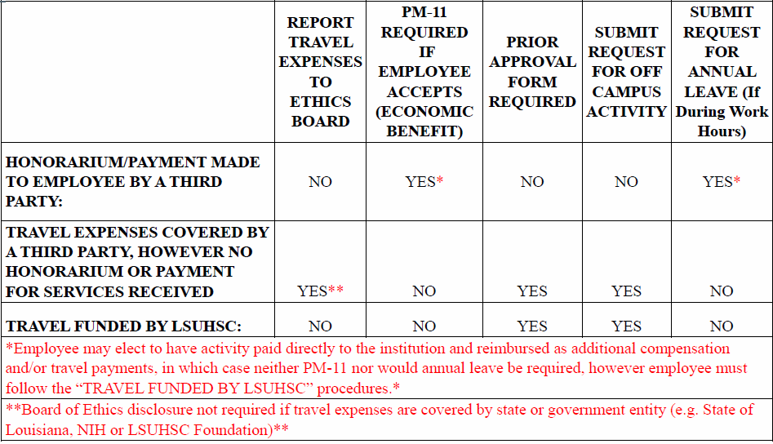

CM-67-Work-Related Off-Campus Activity Policy

